Exp. 1. Simulation of scattering and absorption of Multi-layer Sphere and Core-Shell Nanoparticle using Mie-Plot tool
Aim: To simulate and analyze the scattering, absorption, and extinction characteristics of multi-layer spheres and core–shell nanoparticles using the Mie-Plot tool.
OUTPUT:
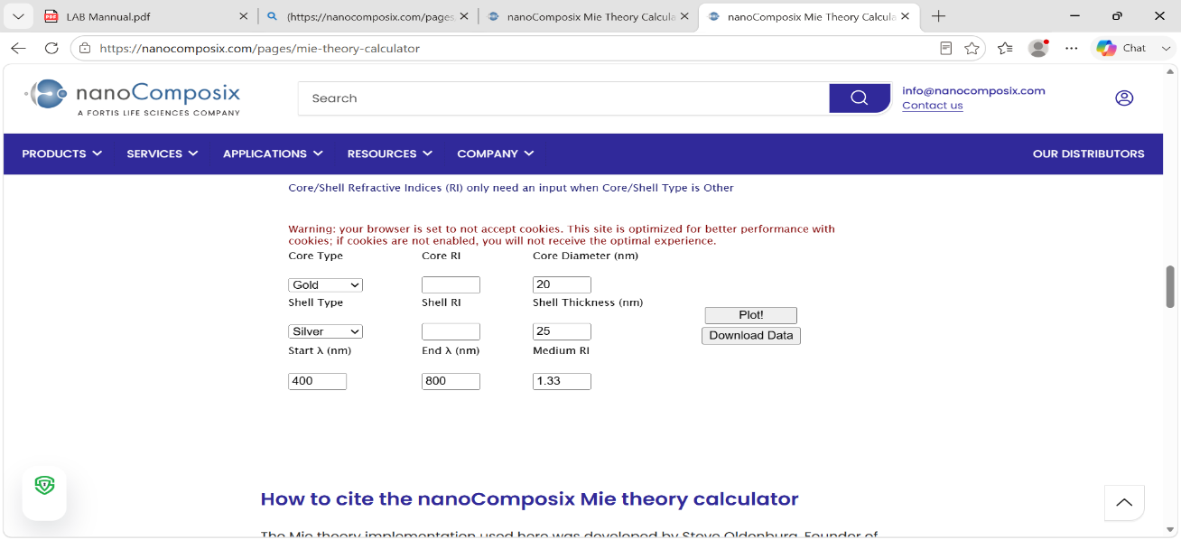
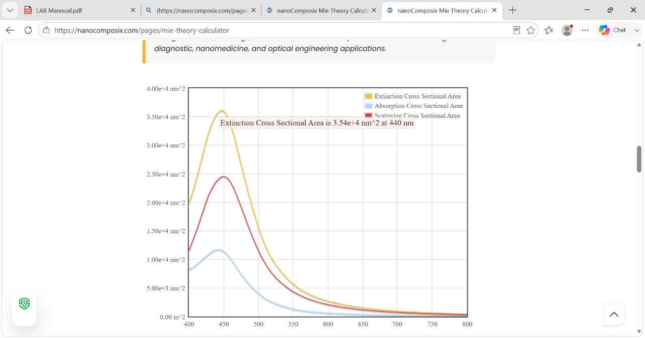

Case Study 1: Scattering and absorption spectra for a single-layer sphere (core only)
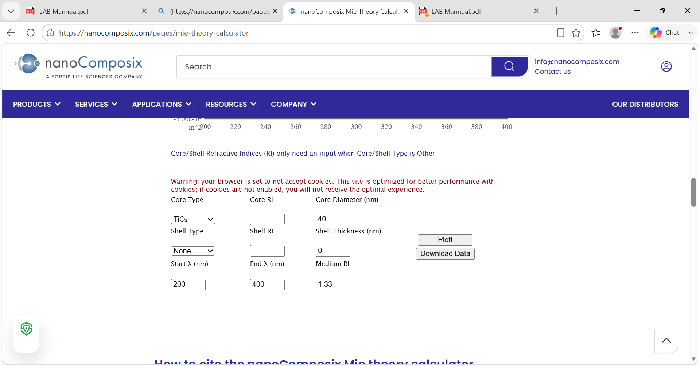
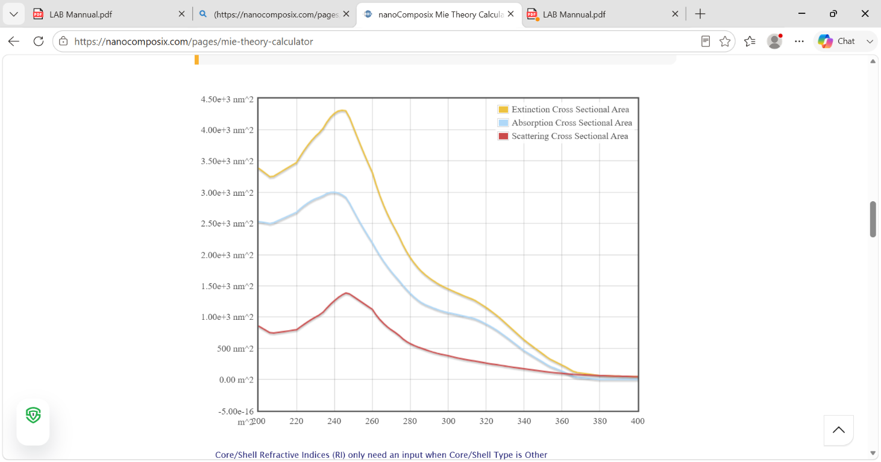

Case Study 2: Simulate the optical response of a gold (Au) nanoparticle of 50 nm diameter in water medium
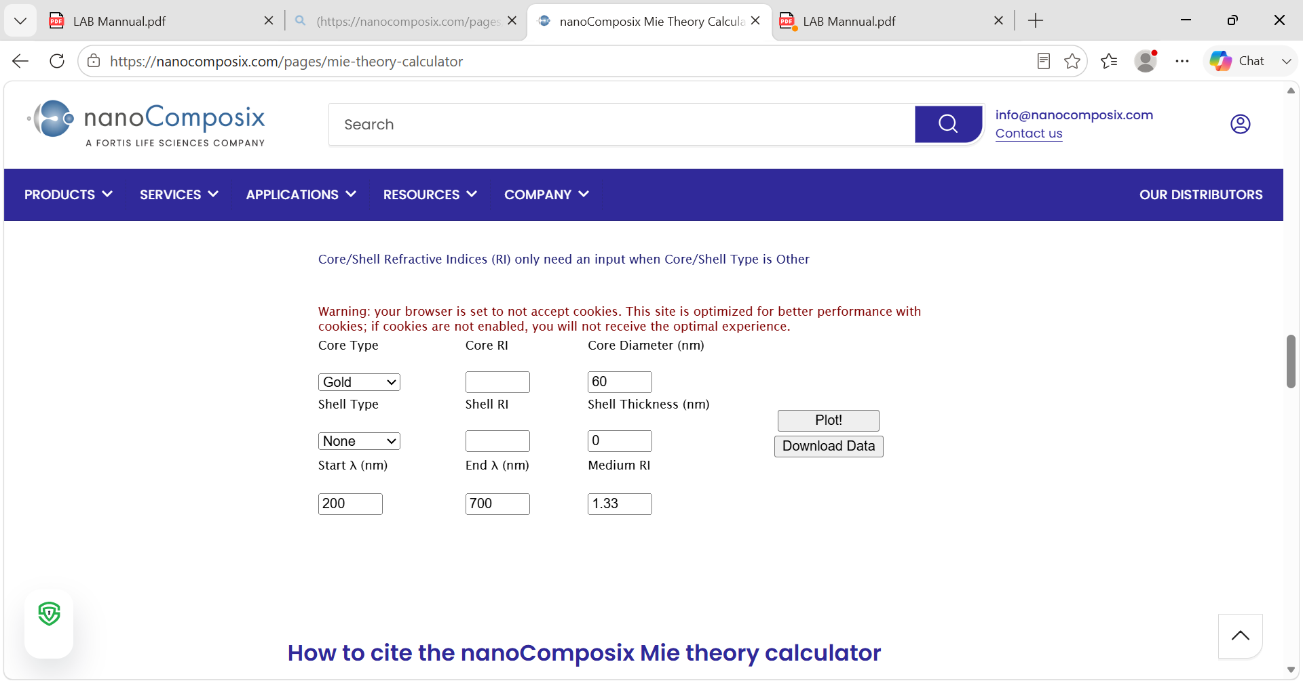
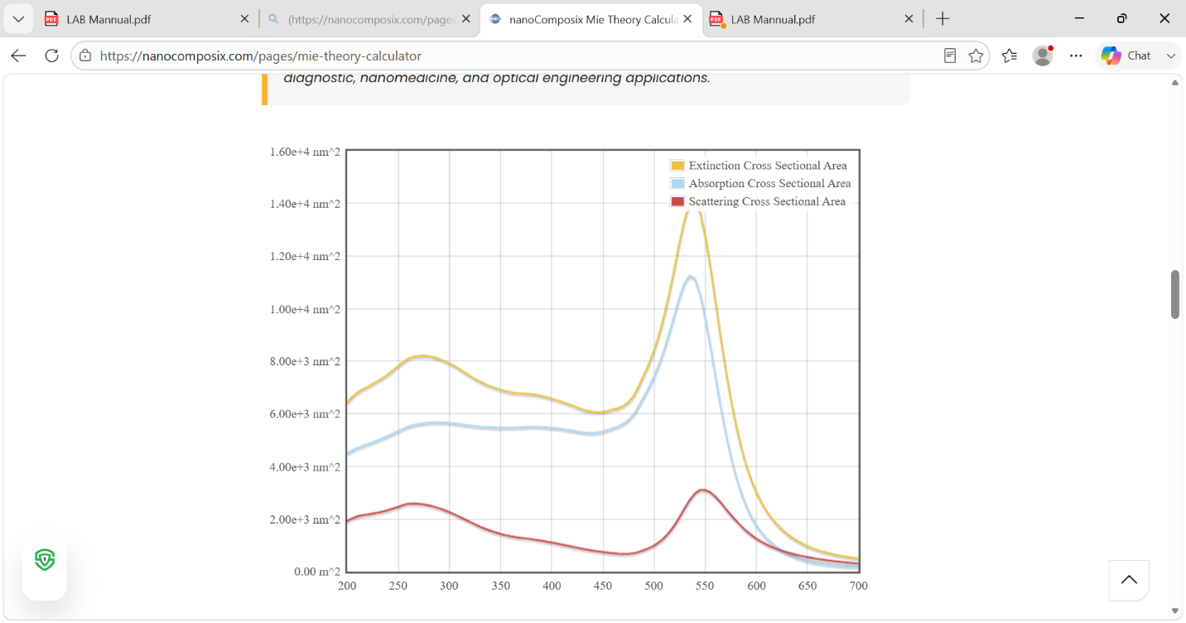

Case Study 3: Simulate a core–shell nanoparticle with a gold core (30 nm) and silica shell (10 nm).
